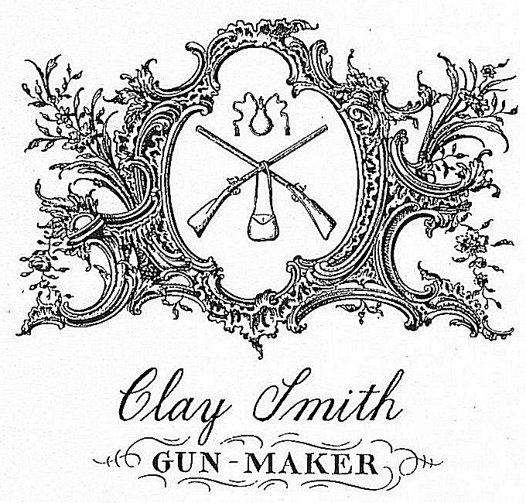 | Clay Smith  Master Gunsmith  4560 Village Park Dr East  Williamsburg, Va. 23185  757-871-9424  E-mail: gunsmith1756@gmail.com Website: claysmithguns.com

Consignment policy:

- If you have something that you want to sell, I will be glad to list it with a consignment fee of 25%.
- Consignment items need to be sent to me. I will then photograph it and list the item on several websites. I will also contact any customers of mine that I believe might have a special interest in the item.
- Figure out the bottom price you will take and I will add my commission to that. If I feel the item might sell for more, I will start the item at the higher price.
- Once the item sells, and the funds clear the bank, I will ship the item to the customer who has a three(3) day inspection period. When the buyer has notified me that the item is acceptable, I will send the owner a check for the price it sold for less the commission.
- If an offer is made by a buyer that is less than the lowest acceptable price with commission, the owner will be contacted for approval.
- If the item(s) do not sell at the agreed upon pricing in 90 days, the prices can be lowered by mutual agreement or the item(s) returned to the owner.
- Shipping costs to send the item(s) to me and any return shipping to the owner will be paid by the owner.
- All buyers of consignment item(s) will pay the shipping cost to receive the item(s) and return shipping cost if they decide not to keep the item(s) during the 3 day inspection period.

Owners Information:
Name: ____________________________________________

Address: ___________________________________________

City, State and zip code: ___________________________________

Phone: ____________________________________________

Email: _____________________________________________

Item # | Description | Lowest Price Acceptable

Owner’s signature: __________________________________________ Date: _____________

